Unit 1 – Activity 6:

Computationally Modeling Change over Time

For this activity you will need an internet-capable computer. Open a browser window and navigate to the following URL:

<https://tinyurl.com/ybshgrfy>

You will see a screen that looks something like this with some information entered on the left-hand window.

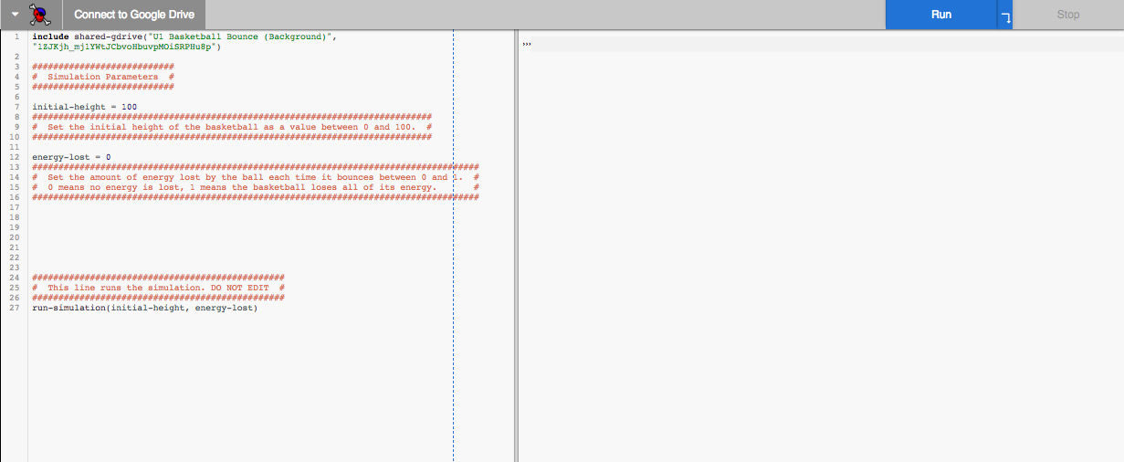

Click the “run” button.

1. What did you observe?
2. Close the “Reactor” window by clicking the “X” in the upper lefthand corner and examine the screen. What types of information do you see on the lefthand side of the screen?
3. Under the heading “Simulation Parameters” you will see two values: *initial-height* and *energy-lost.* These represent the height of the basketball in centimeters before it begins to fall and the amount of energy transferred to the “internal energy” storage account each time the ball bounces. Make a note of these preset values—you will need to return to them later.

Initial-height ________________

Percent-energy-lost *________________*

1. If you were to change the value of *energy-lost* to a larger number, what would you expect to change in the simulation?
2. Try it. Then click “run” again. How was the simulation different from before?
3. What would you expect to happen if you made the *percent*-*energy-lost* significantly larger than it was originally?
4. Try it and describe what happens.
5. Return the *percent-energy-lost* to its initial value. Now predict what will happen if you increase the *intial-height* value?
6. Try it and describe what happens.